Reading Stage | Types of Books | Potential Books & Authors to use | Activity Ideas
Stage 1: Initial development of ‘love for reading’ through interaction/ sharing stories, experience of stories and being read to.  - Demonstrating interest in stories (books or aloud)  - Early listening and attention skills.  - Sharing attention in the book/pictures/object  - Plays with books, pencils, writing tools  - Tries to turn pages/ exploring pages (pop up books/flap books/texture books/board books), attempts to hold and handle and book appropriately.  - Attending and enjoying language and music (nursery rhymes/ songs/rhythm)  - Babbling/ vocalising to react  - Exploration of language/ rhythm  - Demonstrating reactions to expressions/ props.  - Touches pictures/pages/sensory props  - Attends to very short stories or pictures when shown. | - Board Books  - Texture Books  - Sound Books  - Picture books  - Sensory Stories  - Flap Books  - Bag Books  - Puppet books | - ‘That not my books’ : Fiona Watt and Rachel Wells  - Mink Inkpen: Wibbly Pig stories  - I Dare you! By Nicole Maubert  - Touch and Explore, Bugs and Other little Creatures by Stephanie Babin  - Split! Splat! Amy Gibson  - Tap Tap Boom Boom Elizabeth Bluemle  - Onomatopoeic books  - Sensory stories  - Story sacks  - Sensory poems  Things to consider when selecting books for pupils:  - The presentation of the book (style of images/characters/cartoon/real images)  - The theme of the book (in relation to Key Stage such as lifestyle/careers/non-fiction themes for secondary school-age)  - The age-appropriateness of book.  - Whether the child has accessed the story multiple times in previous years.  - Whether the book is being used in other Key Stages. | - Rhyme time- Sharing rhymes as a group, reciting rhymes, pupils hearing rhymes, singing rhymes throughout the day as part of the daily routine  - Nursery rhymes – Use of props to re-tell rhymes, acting out nursery rhymes  - Anticipation using props- Pulling out props from bags at points in stories and songs to introduce characters  - Explore board books- turning pages and being hands on with books independently  - Making picture books- Topic based photos, Photos of pupils on a trip, activities they have taken part in, family, friends, preferred topics  - Dance massage - music-led experience that fosters connection through rhythmic touch and sensory tools applied to the upper body and hands  - Resonance boards – exploring percussion, feeling the story through vibrations and sounds  - Puppet shows  - Massage stories  - Tac Pac  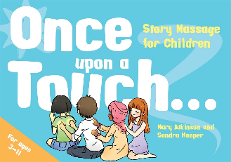  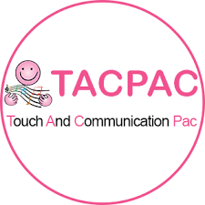  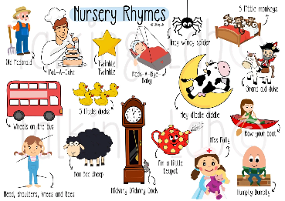
Reading Stage  Stage 2: Exploration and curiosity in physical books/pictures stories  - Explores pictures and vocabulary/ key words  - Language exploration, exposure to key words/signs/ symbols.  - Listening and identifying environmental sounds  - Points to pictures of their own interest.  - Demonstrating anticipation related to story not objects.  - Choosing book/demonstrating favourite stories  - Using pictures to tell stories/ to create own stories  - Turns pages several at a time, holds a book the correct way up, handles books appropriately.  - Responding to being read a story/physical book.  - Experiences and is aware of different types of texts.  - Anticipating repetitive phrases  - Naming/ pointing to objects from books from simple choices.  - Recognises the covers of favourite books.  - Attends for the duration of a short, simple story with prompting. | Types of Books  - Picture Books  - Rhyme/Rhythm books  - Repeated Phrase books  - Onomatopoeia books  - Looking books  - Nursery Rhymes and Songs | Potential Books & Authors to use  - Brown Bear by Bill Martin and Eric Carle  - Mick Inkpen: Kipper Series  - Helen Oxenbury stories  - Mick Inkpen: Kipper Series (Lower Key stage 2)  - Usborne farmyard tales  - I ain’t gonna paint no more by Karen Beaumont  - Monkey Puzzle, The Gruffalo, What the Ladybird Heard, Superworm, Squash and a Squeeze by Julia Donaldson  - Nick Butterworth  - Julia Donaldson: Stick Man, The Snail and the Whale, The Smeds and the Smoos.  - Janet and Allberg books (Funny Bones)  Things to consider when selecting books for pupils:  - The presentation of the book (style of images/characters/cartoon/real images)  - The theme of the book (in relation to Key Stage such as lifestyle/careers/non-fiction themes for secondary school-age)  - The age-appropriateness of book.  - Whether the child has accessed the story multiple times in previous years.  - Whether the book is being used in other Key Stages. | Activity Ideas  - Activity books- Create a book of photos from a trip or activity, pupils to choose photos, answer simple questions about what is happening in the photos  - Characters- Labelling scenes and identifying key characters in books  - Repetitive refrains- ‘Billy Goats Gruff’, ‘Peace at Last’, ‘Gingerbread Man’, ‘Brown Bear Brown Bear’. Record pupils saying repetitive refrains or making sounds for stories to play as you re-tell the story  - Anticipation- Providing anticipation through delivery of props during storytelling, use of language.  - Sharing storytelling- Passing props and books around a circle to peers  - Musical stories- Telling stories through music by singing/playing songs that relate to each part of a story. You could make up your own story to go with the songs.  - Props- Choosing props to go in a story and create their own story sack  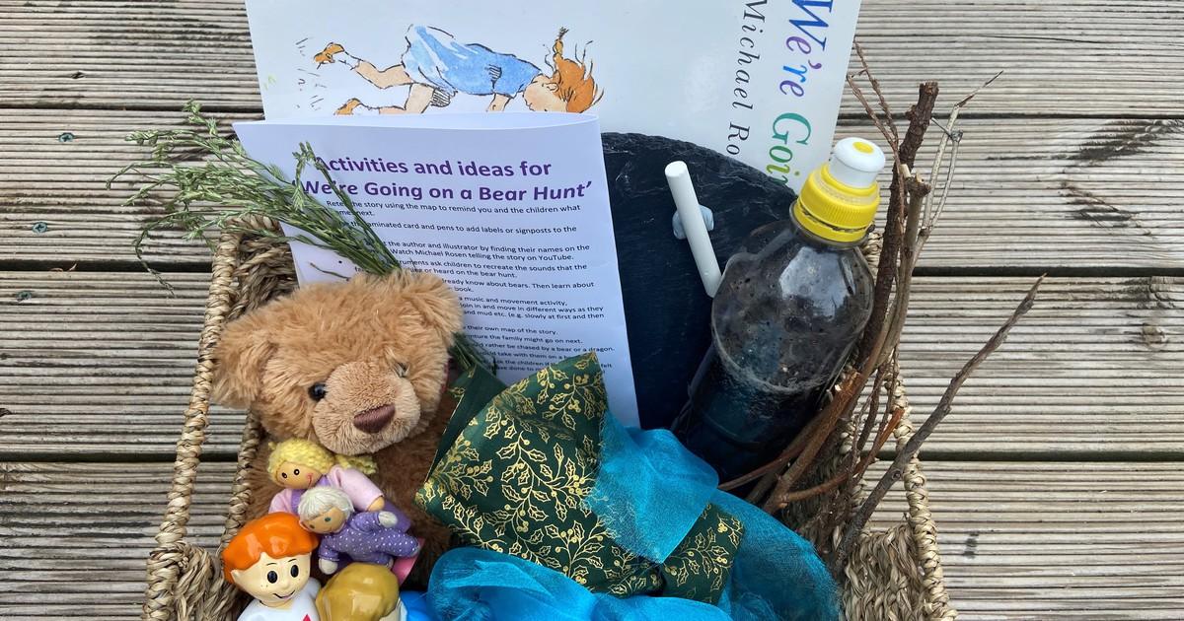  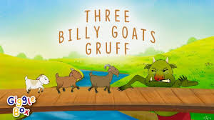  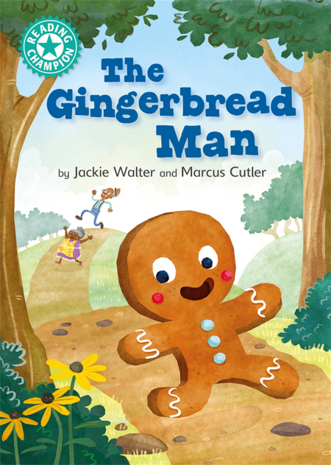
Reading Stage  Stage 3: Emerging understanding of story they have listened to and that understand that books have meaning  - Pointing to identify/ demonstrate comprehension of plot/character.  - Gaining/ using information from pictures.  - Retelling stories using own choices to change plot.  - Anticipating, responding to familiar parts of the story.  - Can join in repetitive phrases or repeated action (using switches/ symbols/voice).  - Turns single pages and works from the start to the end of the book.  - Answers what/who questions from a choices.  - Remembers a short sequence of events from familiar stories using symbols/objects/pictures.  - Recites favourite lines from story.  - Chooses to play and explore stories  - Independently attends to for the duration of a short story.  - Will choose a single word to fill in the blank from a line in a familiar story.  - Can say/match/identify single sounds for 10+ graphemes. | Types of Books  - Sequencing books  - Books with simple plots with pictures  - More complex pictures (can use information in pictures to understand what is happening, not just pointing to objects when named)  - Repeated Phrases | Potential Books & Authors to use  - Sue Hendra stories  - Julia Donaldson: Stick Man, The Snail and the Whale, The Smeds and the Smoos.  - Nick Butterworth Farm Stories  - Hairy Mclary by Lynley Dodd  - Twisted Fairytales  - The Little Red Hen by Jerry Pinkney  - Hairy Maclary’s Bone by Lynley Dodd  - Large Family Series by Jill Murphy  Things to consider when selecting books for pupils:  - The presentation of the book (style of images/characters/cartoon/real images)  - The theme of the book (in relation to Key Stage such as lifestyle/careers/non-fiction themes for secondary school-age)  - The age-appropriateness of book.  - Whether the child has accessed the story multiple times in previous years.  - Whether the book is being used in other Key Stages. | Activity Ideas  - Colourful semantics- Using colourful semantics to create sentences about stories, to answer questions, to caption pictures.  - Questions- Answering ‘who’ ‘what’ ‘where’ questions about a story/plot/character  - Changing the story- Use the plot of an original story and change the characters/adapt the plot  - Building a story- Making a story based on a favourite topic (Fairy Tales), ‘You Choose’ books.  - Drama- Acting out a story, moving like a character, moving to music to re-tell a story  - Reciting/acting out Poems  - Focus on key-words in a story- Verbs, adjectives, adverbs, nouns.  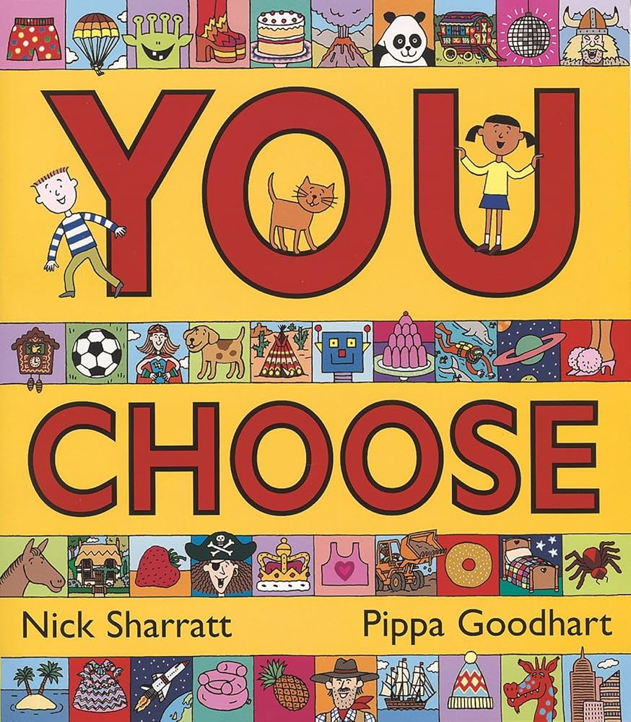  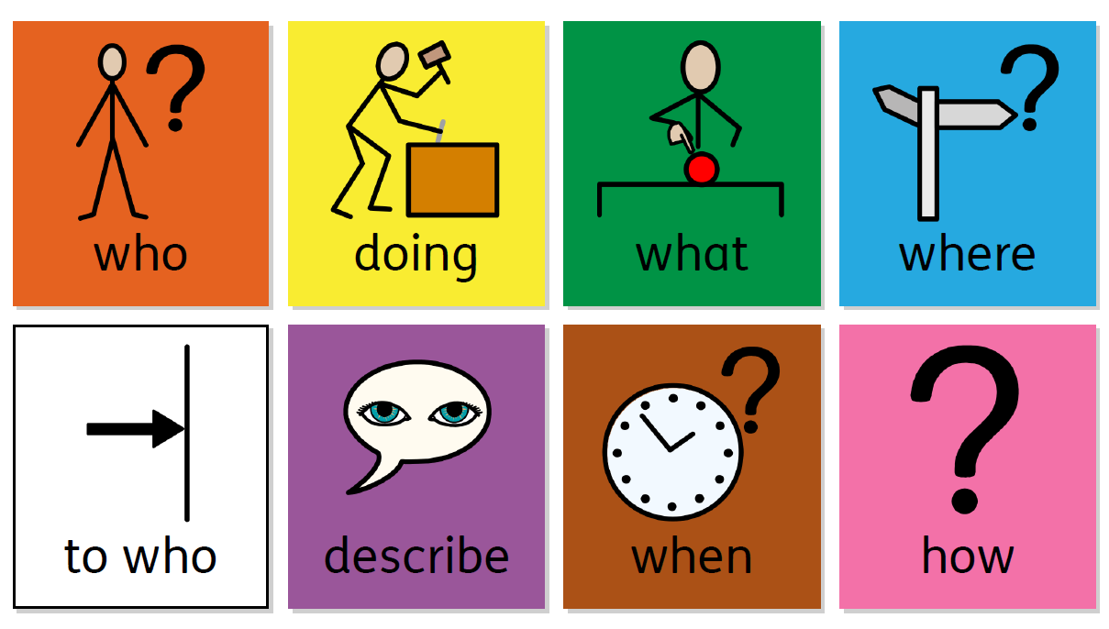  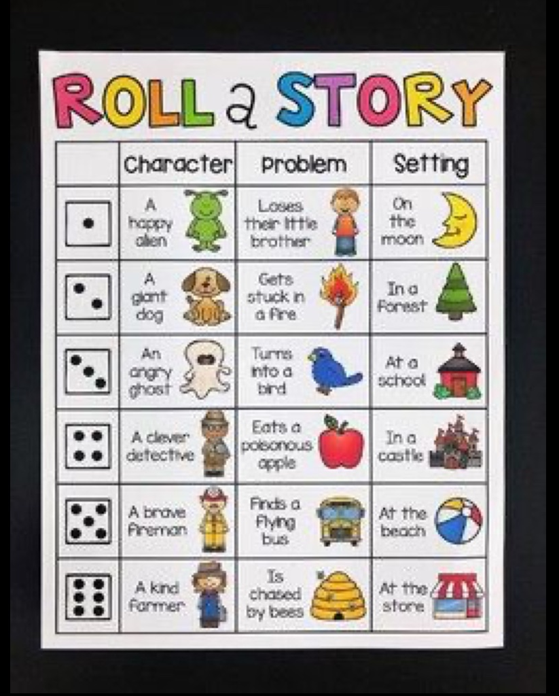  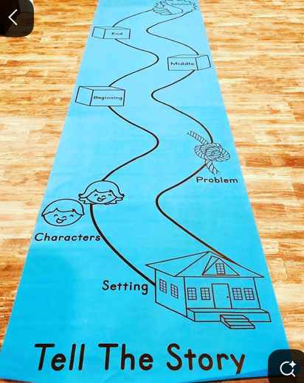
Reading Stage  Stage 4: Developing and extending comprehension of stories.  - Describes settings/ characters/ using simple adjectives.  - Answers who/what/ where questions using symbols with choices.  - Says if they like or dislike the story.  - Creating sentences about or related to the book using symbols.  - Identifies/ summaries a sequence of events in a story.  - Retell a story in order using pictures/ words/symbols/switches.  - Predicts what will happen next in a story.  - Can attend to longer stories.  - Correct reader when the story is wrong.  - Can say/match/identify single sounds for 20+ graphemes. | Types of Books  Sequencing stories  Stories to adapt  Longer stories with more complex plots  Comic strips | Potential Books & Authors to use  - Suddenly by Colin McNaughton  - The True Story of the Three Little Pigs by Jon Scieszka  - Favourite mixed up fairy tales by Hilary Robinson  - Winnie The Witch by Valerie Thomas  - The Book of Fantastic First Poems by June Crebbin  - Oxford Reading Tree Scheme Stage 1.  Things to consider when selecting books for pupils:  - The presentation of the book (style of images/characters/cartoon/real images)  - The theme of the book (in relation to Key Stage such as lifestyle/careers/non-fiction themes for secondary school-age)  - The age-appropriateness of book.  - Whether the child has accessed the story multiple times in previous years.  - Whether the book is being used in other Key Stages. | Activity Ideas  - Story trays- Build up scenes in trays, character trays  - Setting the scene- Bringing settings from stories to life in the classroom- tents, smells, lights, sounds  - Story sticks and story ropes- Adding props, resources, pictures to a stick or rope to sequence a story and then re-tell it.  - Story sequence switches  - Identifying missing words in a familiar story or rhyme  - Story maps – identifying different parts of the story; beginning, middle and end  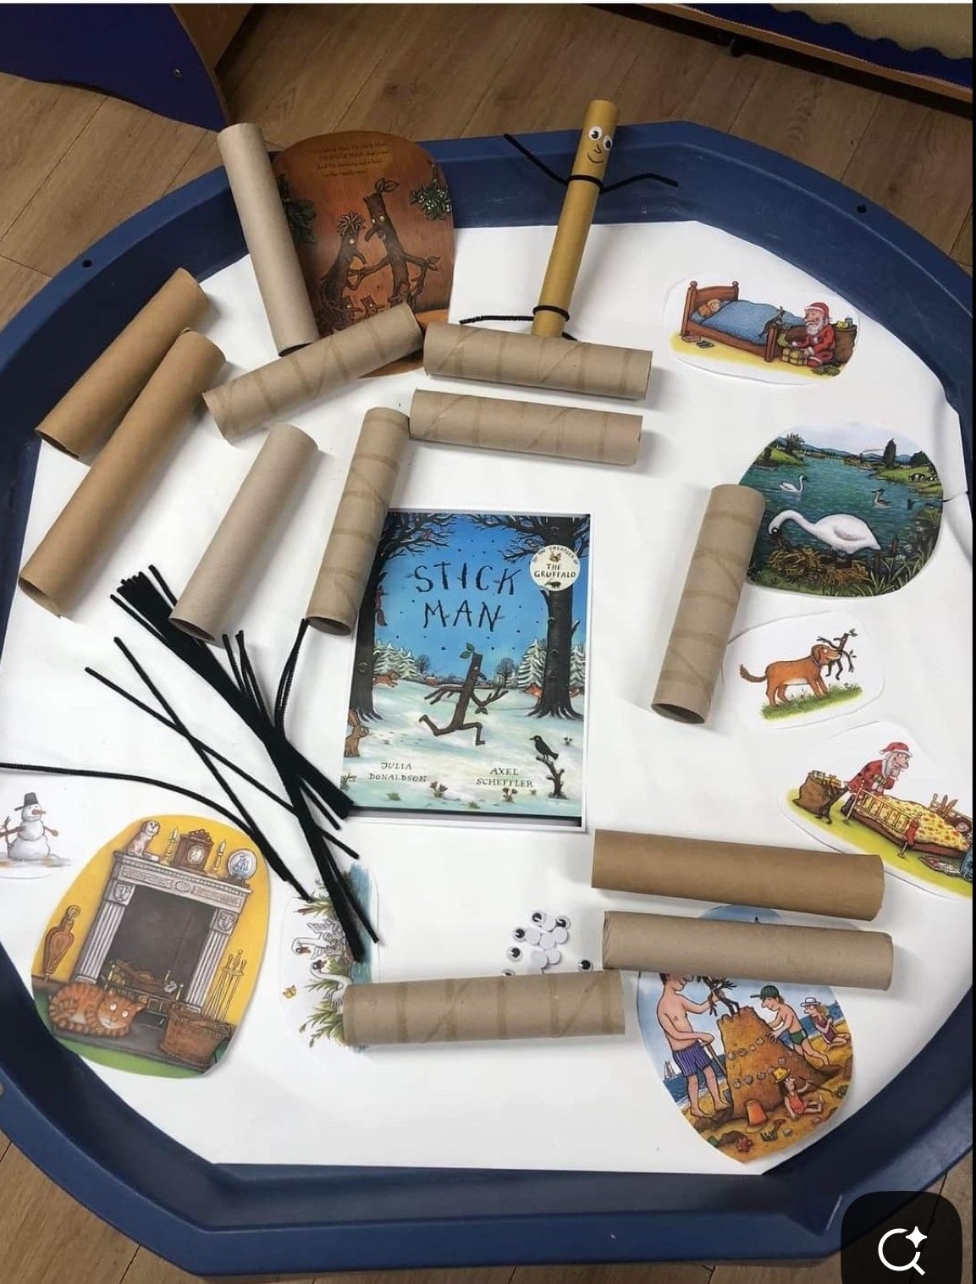  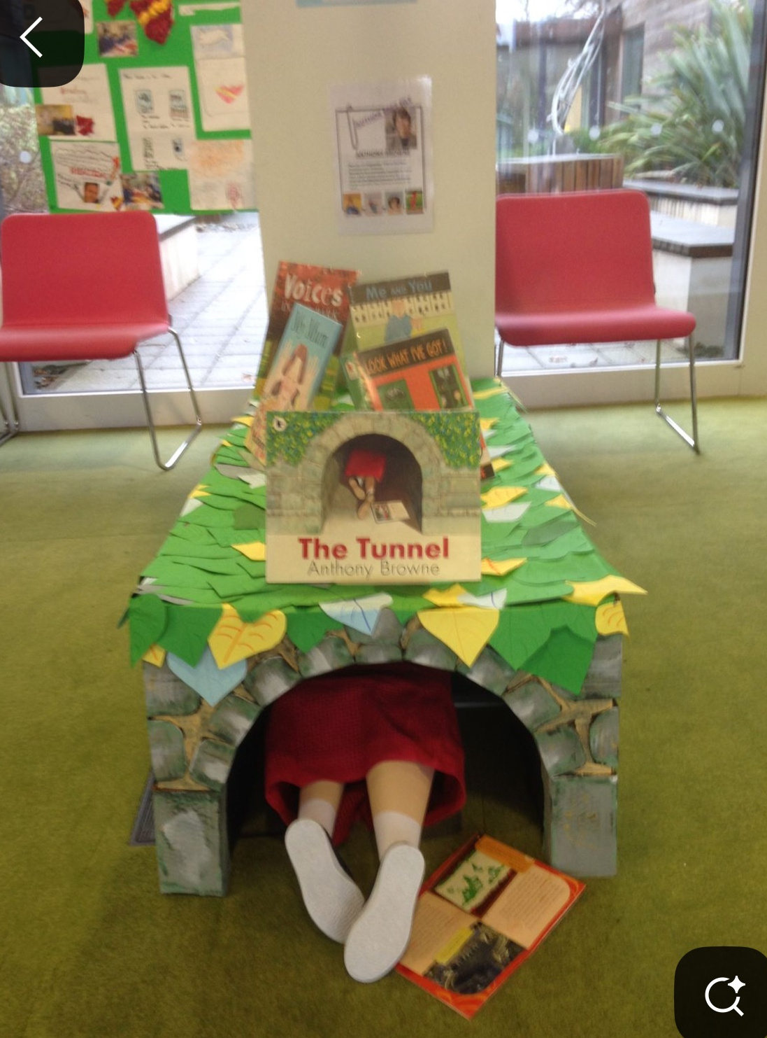  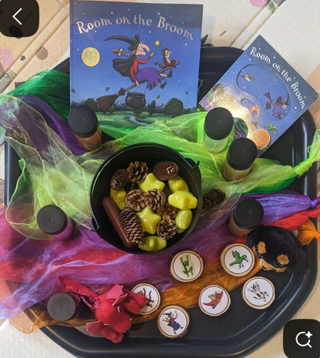  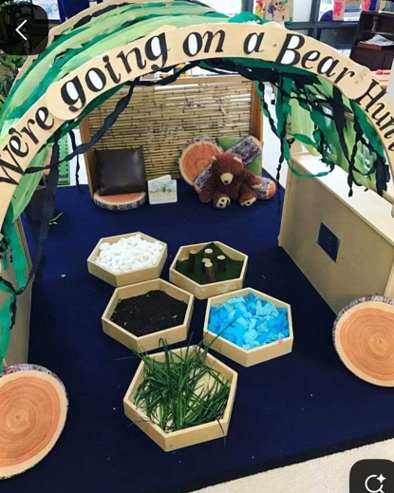  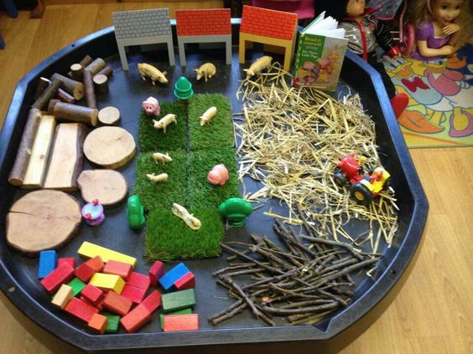  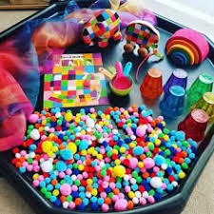  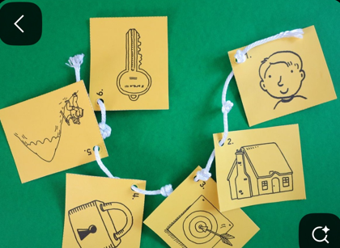  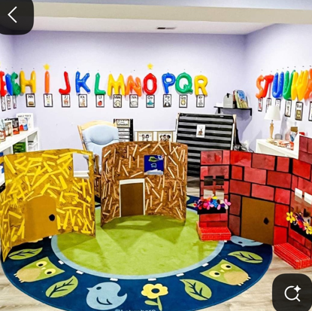
Reading Stage  Stage 5: Emerging readers  - Matching rhyming couplets  - Can say/match/identify single sounds for 40+ graphemes.  - Finding letter sounds in words  - Segment words into letter sounds  - Blend words to read with known graphemes, with prompting.  - Spell words using letter sounds  - Start matching words they hear to words they see on the page  - Sound out words (CVC, CVCC, CCVC)  - Recognising initial and end sounds to words  - Can read some common exception words. | Types of Books  Picture Stories to build own narrative from.  Rhyming stories  Story books with longer, more detailed and abstract plots | Potential Books & Authors to use  - The Princess and the Wizard by Julia Donaldson + Lydia Monks.  - A River by Marc Martin  - Planet Rescue by Patrick George  - Silly Poems complied by Paul Cookson  - The Rhyming Rabbit by Julia Donaldson  - A Packet of Poems by Jill Bennett and Paddy Mounter  - The Book of Fantastic First Poems by June Crebbin  - Oxford Reading Tree Scheme  Things to consider when selecting books for pupils:  - The presentation of the book (style of images/characters/cartoon/real images)  - The theme of the book (in relation to Key Stage such as lifestyle/careers/non-fiction themes for secondary school-age)  - The age-appropriateness of book.  - Whether the child has accessed the story multiple times in previous years.  - Whether the book is being used in other Key Stages. | Activity Ideas  - Sharing and listening to poems  - Aspect 4 activities- Rhythm and Rhyme- Pre-Phonics  - Aspect 5 activities- Alliteration- Pre-Phonics  - Rhyming books  - Learning Songs and Rhymes  - Alliteration Story- Who, What, Where?- Choices all begin with the same letter sound to create an alliteration story  - CVC word books  - Labelling pictures with CVC words  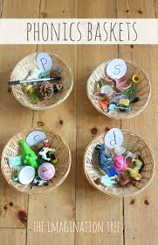  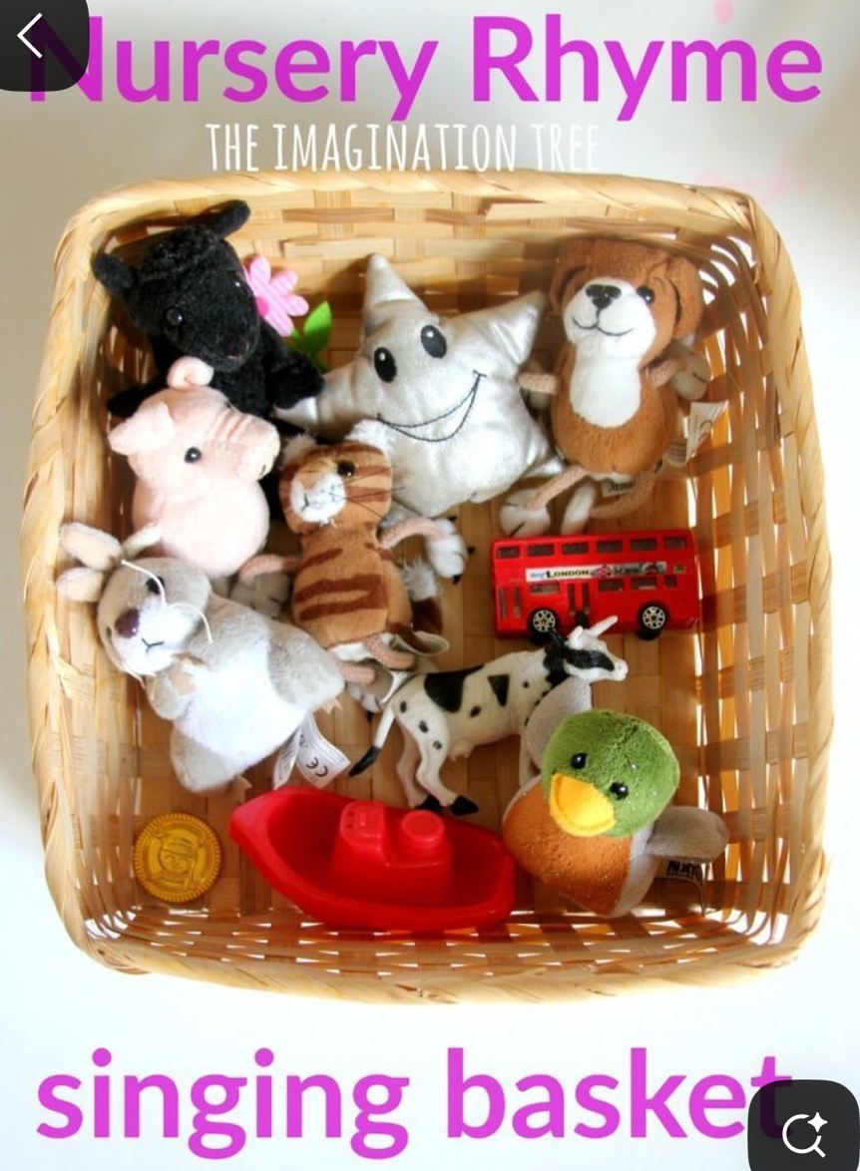  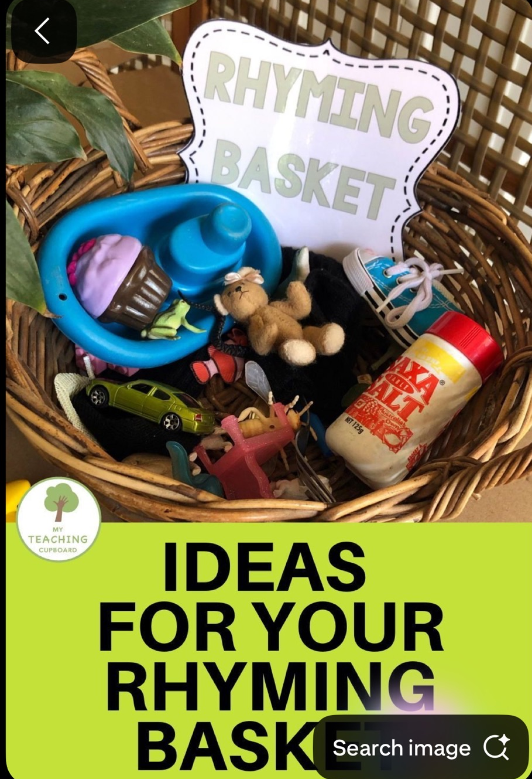  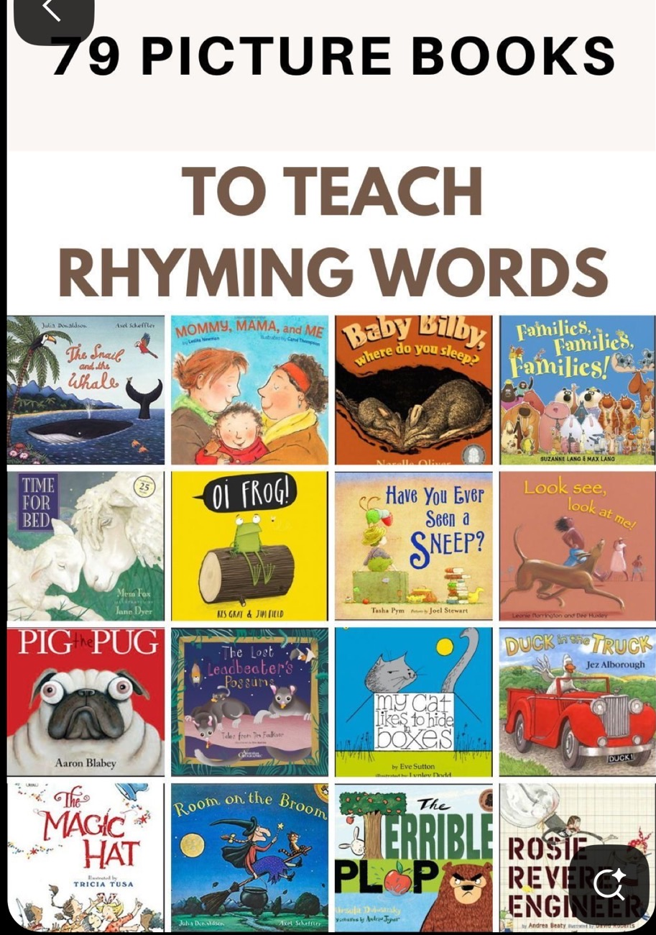  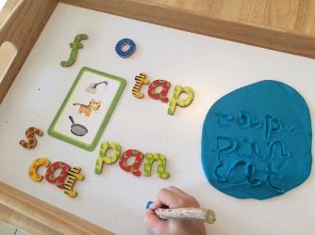  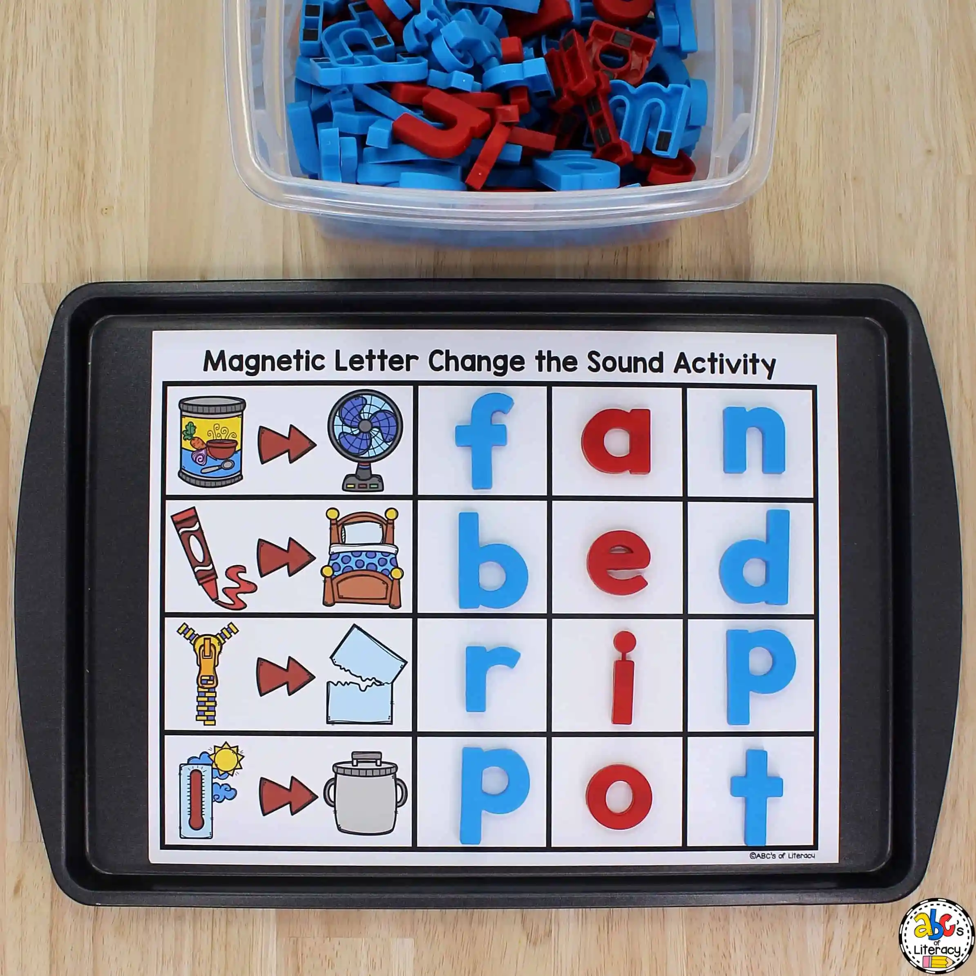  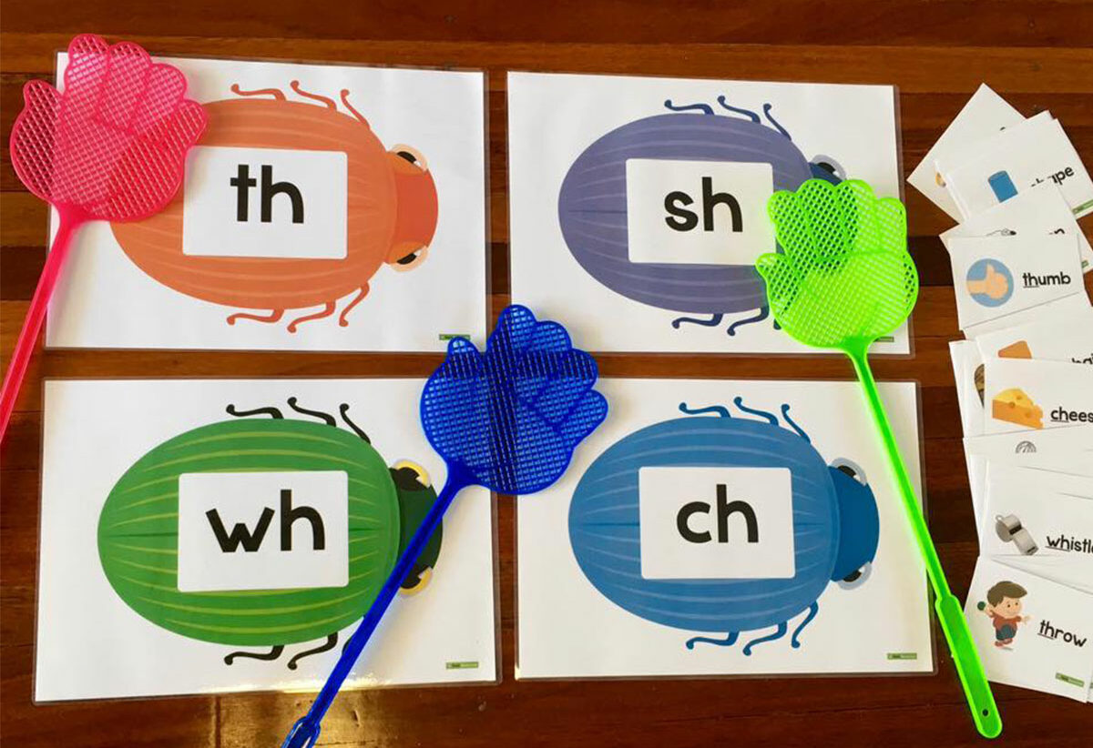
Reading Stage  Stage 6- Readers  - Understands homophones, split diagraphs and trigraphs.  - Recognises and can read high frequency words  - Start recognising some words by sight without having to sound them out  - Improve reading speed and fluency  - Go back and re-read a word or sentence that does not make sense.  - Read for different purposes, for example enjoyment or to learn something new  - Describe the setting, characters, problem/solution, and plot of a story.  - Compare and contrast information from different texts.  - Refer to evidence from the text when answering questions about it.  - Makes inferences by using clues from the text and prior knowledge.  - Identifying and discussing aspects of grammar in the text.  - Summarising what happened in a story.  - Giving reasons behind what is happening in a text.  - Reading books aloud books that are consistent with their phonics knowledge. | Types of Books  Picture Stories to build own narrative from.  Rhyming stories  Story books with longer, more detailed and abstract plots | Potential Books & Authors to use  - Once upon Raindrop: James Carter and Nomoco  - Never show a T-rex a book by Rashmi Sirdeshpande & Diane Ewen  - The Jolly Postman by Janet and Allen Alberg  - Journey by Aaron Becker  - Shhh! We have a plan by Chris Haughton  - Dr Seuss Stories  - Oxford Reading Tree Scheme  Things to consider when selecting books for pupils:  - The presentation of the book (style of images/characters/cartoon/real images)  - The theme of the book (in relation to Key Stage such as lifestyle/careers/non-fiction themes for secondary school-age)  - The age-appropriateness of book.  - Whether the child has accessed the story multiple times in previous years.  - Whether the book is being used in other Key Stages. | Activity Ideas  - Exploring verbs and adjectives within stories and when creating stories  - Acting our verbs in stories within drama activities  - Re-telling stories using the verbs that occur in them.  - Finding objects within stories to re-tell it.  - Using pictures to order events in a story.  - What happens next?- Predicting what may happen next or recalling what happens next.  - Recall games- What was the missing object?  - ‘Reading for Meaning’  